As a wardrobe consultant, I help clients refine their wardrobe and get their closet into stylish shape.
By hiring me as your wardrobe consultant I will be streamlining your closet and stocking you with outfits you will actually wear by getting realistic (and affordable) solutions for your fashion dilemmas.
Pro help is invaluable for improving your professional image and boosting your self esteem.

If you answer yes to any of the questions below then you're on the right track to seeking a consultants advice.
1. Is my closet packed with clothes but I feel like I never have anything to wear?
2. Do I wear a few of my clothes all the time and leave everything else hanging?
3. Do I have some gorgeous pieces of clothing that I never wear because I'm not sure how to pull them off in an outfit?
4. Does my closet feature items I really like, and will put on, but then always take off and go back to my comfort zone?

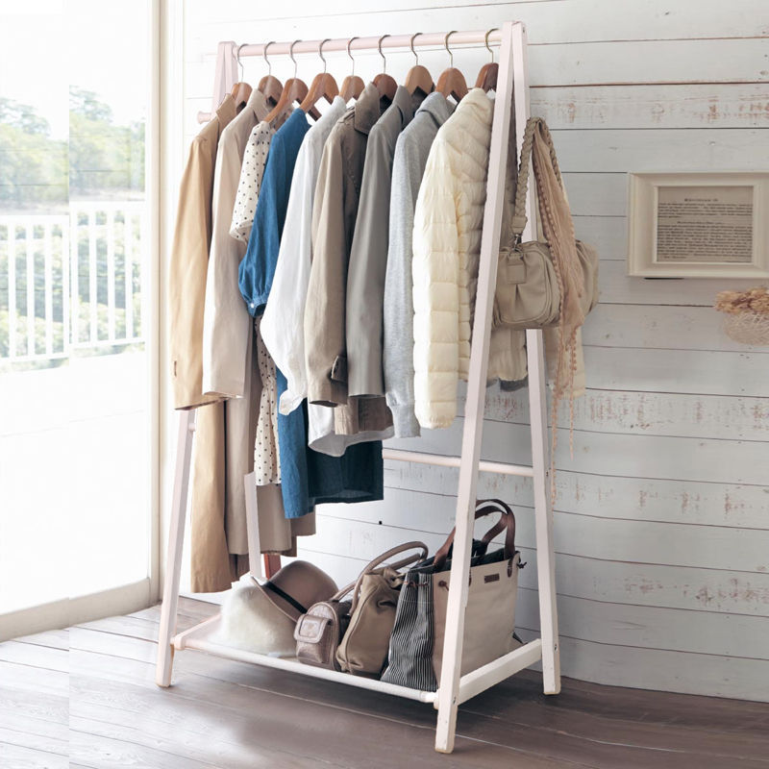
Wardrobe Building Plan
* Pair outfits to gain multiple outfits
* Suggest new items to add ( Staple Pieces)
(Package 1)

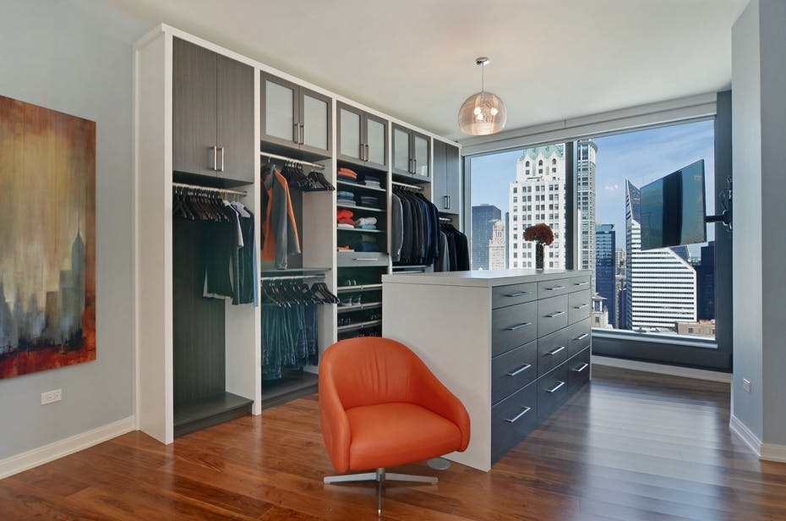

Closet Re-Pair

*Conduct an intake meeting to determine your needs which will be done in person or by phone. 30min
*Outline your desired requests and style choice
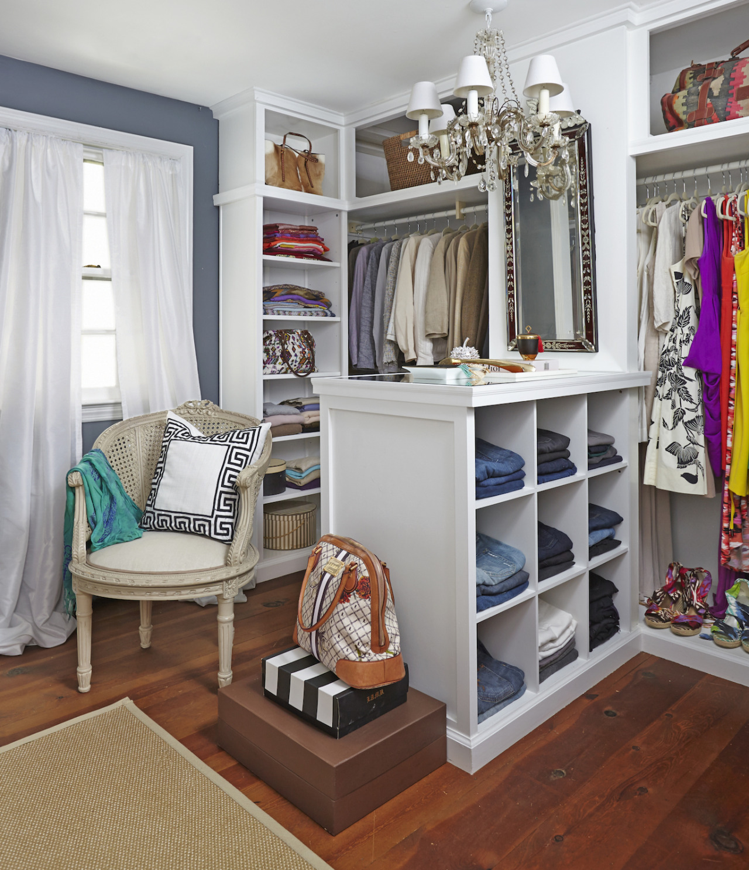* Complete a Closet Cleanse
(meaning I take stock of each item of clothing you own and coach you on what stays, what goes)
*I will suggest what new items you need and how to pair them with current items
*Pair items in different ways
* Reorganize closet ( Garment and Color coordinate) )
(Package 2)

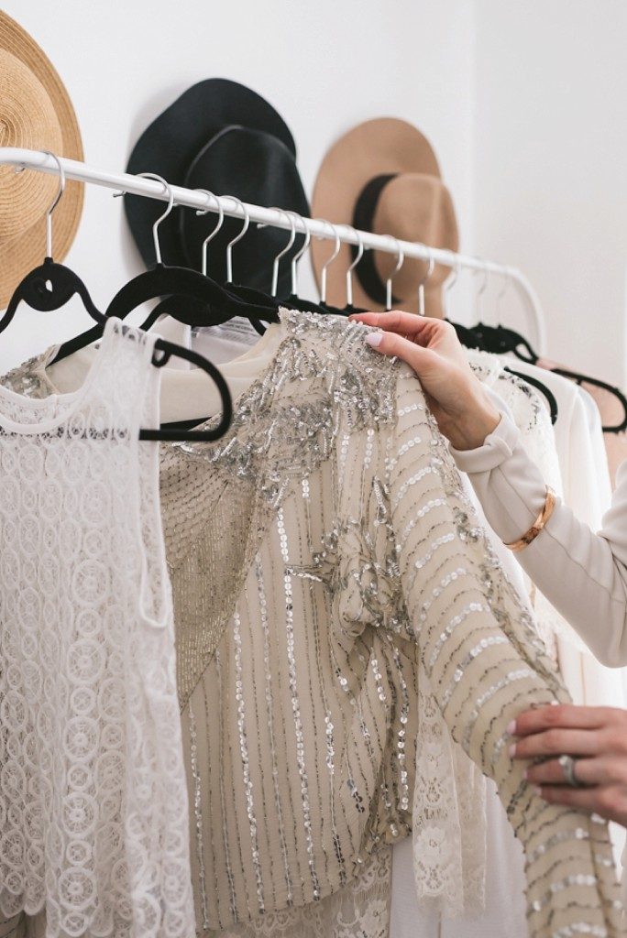Wardrobe Re-fresh

*Conduct an intake meeting to determine your needs which will be done in person or by phone.
(Outline desired requests and style choice)
* Complete a Closet Cleanse
(meaning I take stock of each item of clothing you own and coach you on what stays, what goes)
*I will suggest what new items you need and how to pair them with current items
*We will pair old items in diferent ways
* Provide game plan to reorganize closet ( Garment and Color coordinate)

*Take the pain out of shopping by doing the dirty work for you
*Host wardrobe fitting
*Conduct returns on your behalf
*Provide crafted look-book that catalogs each outfit down to the accessories so that you don't have to think about it anymore and each look is fabulous and ready to roll!
(Package 3)

